**Defect Report**

* **Defect Id: 18**
* **Status: New**
* **Reported by: Bishoy**
* **Asserted to: Malek**
* **Date:**  **13/5/2023**

**Defect description: after entering an empty value for student activity mark, an** *INVALID_STUDENT_ACTIVITIES_MARK* **exception must be thrown but an** *UnExpectedException* **Type Thrown. Student activity mark must be an integer value ranges from 0 to 10**

* **Steps:**

1. **Open the application**
2. **Enter the student activity mark = null**
3. **Run the program**

* **Severity: High**
* **Priority: High**
* 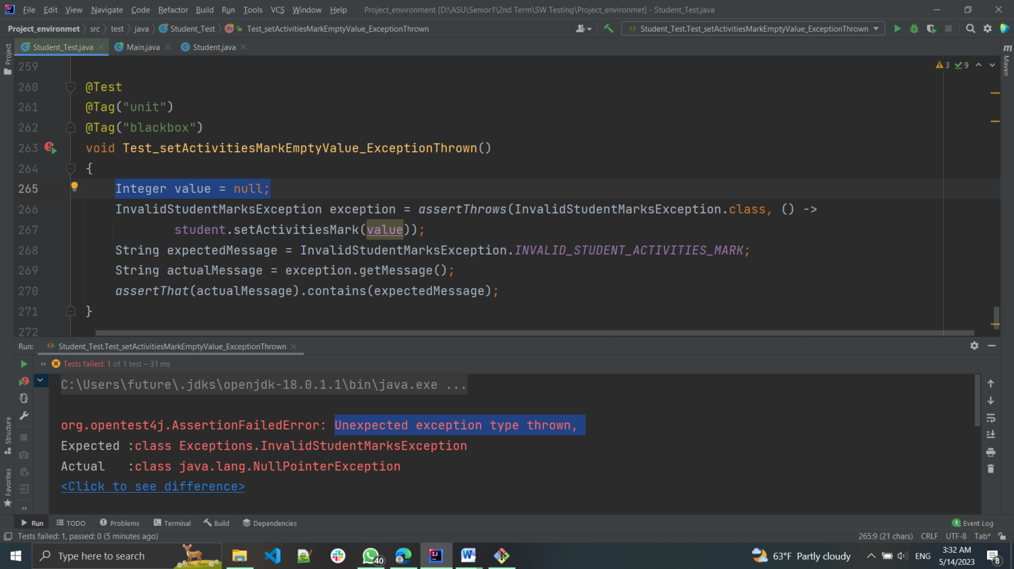**Screenshot for the Defect:**
* **Screenshot after fixing:**